

**JUNE 2025 Surgery Newsletter**

**Tendring Primary Care Network Patient and Wellbeing Fair**

As promised in the May Surgery Newsletter, please see the poster below advertising our Community Health and Wellbeing Fair. We would encourage as many patients as possible to attend this event, which we hope you will find to be informative and of benefit to you.

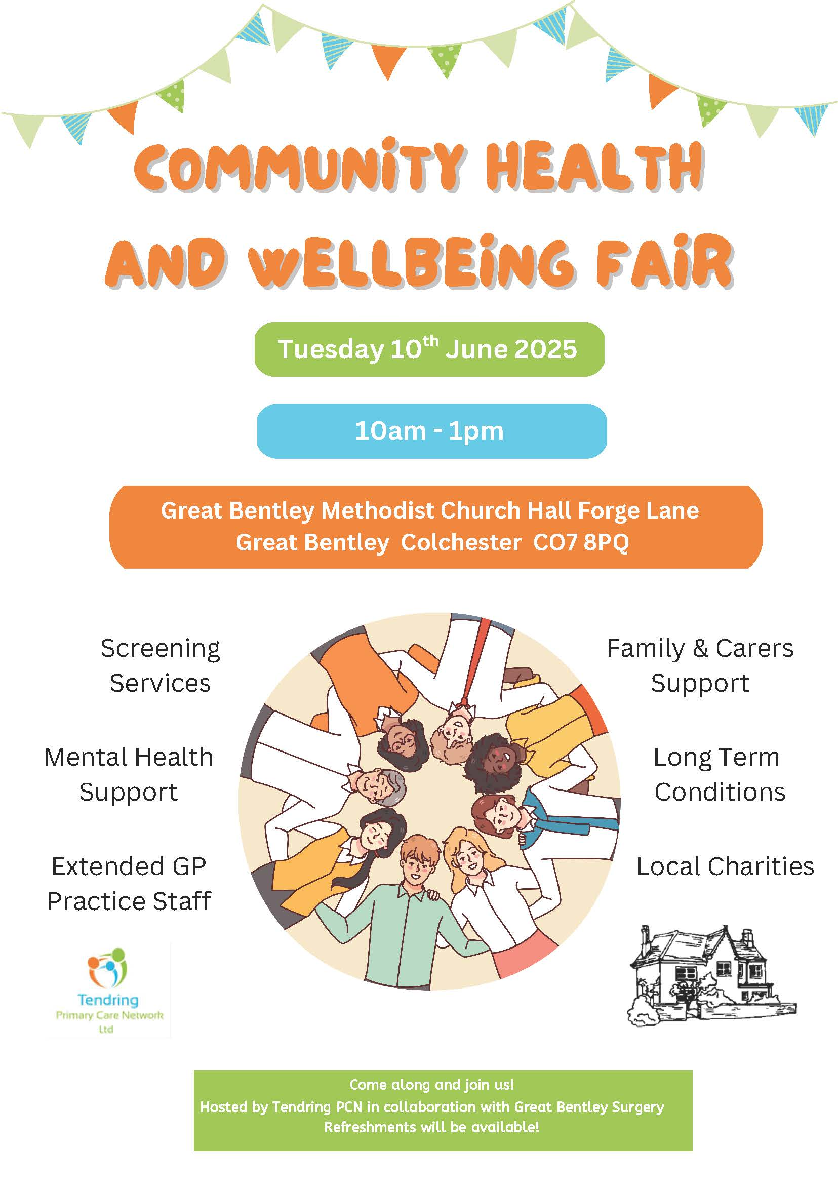

**Surgery Training Afternoon**

Along with all other surgeries in the area we will be shut from 12 noon on Thursday, 26 June 2025 for staff training. If patients require urgent medical care on this afternoon, then this is available by contacting NHS 111 for assistance.

**Patient Participation Group Meetings**

There will not be a Patient Participation Group meeting in June.

**Sue Mitson – Operations Manager**